Supporting information:

Denoising NMR time-domain signal by singular-value decomposition accelerated by graphics processing units
Pascal P. Man*^{a,b}, Christian Bonhomme^{c,d}, Florence Babonneau^{c,d}
ªSorbonne Universités, UPMC Univ Paris 06, FR 2482, Institut des matériaux de Paris-Centre, Collège de France, F-75005, Paris, France
^{b}CNRS, FR 2482, Institut des matériaux de Paris-Centre, Collège de France, F-75005, Paris, France
^{c}Sorbonne Universités, UPMC Univ Paris 06, UMR 7574, Chimie de la Matière Condensée de Paris, Collège de France, F-75005, Paris, France
^{d}CNRS, UMR 7574, Chimie de la Matière Condensée de Paris, Collège de France, F-75005, Paris, France

*Corresponding author.
E-mail address: pm@pascal-man.com
Singular-value decomposition
It is shown [1–3] that any non-square mxn (m > n) complex matrix $M$ can be factorized as:
$M(m×n)=U(m×m)Σ(m×n)V^{}(n×n)$ (S1)
where $U$ is an mxm complex unitary matrix, $Σ$ an mxn rectangular diagonal matrix with non-negative real numbers on the diagonal sorted in descending order ($M$ and $Σ$ are of the same dimensions) and $V^{}$ (the conjugate transpose of $V$) an nxn complex unitary matrix. The diagonal entries $Σ_{\text{ii}}$ of $Σ$ ($Σ_{i}$ for short) are called singular values of $M$ with $Σ_{1}≥Σ_{2}≥\text{.}\text{.}\text{.}Σ_{n}≥0$. $U$ is called the left singular vector matrix and $V$ the right singular vector matrix. Another decomposition [4] is possible for $M$:
$M(m×n)=U(m×n)Σ(n×n)V^{}(n×n)$. (S2)
As NMR time-domain signal is recorded in quadrature detection, the matrix elements of the Hankel matrix $M$ are complex numbers. We provide a first program [5] that uses the programming language Java. It includes a Java package for matrix computations called JAMPACK (JAva Matrix PACKage) developed by Stewart [6]. This package implements the SVD of double-precision complex matrix. Our program executes in any operating system containing a Java virtual machine. We also provide a second program [7] executing only in Windows-system computer equipped with modern GPU that dramatically improves the SVD execution performance. SVD procedure with single-precision complex numbers for GPU is freely distributed by CULA [8]. We compare our two programs in 64-bit Windows-7 operating system using an HP Z400 workstation equipped with Intel Xeon W3530 quad-core processor and an Nvidia Quadro 4000 GPU. The results are shown in . For typical condition in solid state NMR, SVD of 1048X1000 Hankel complex matrix requires only 2 s instead of 80 s without GPU.
²⁹Si MAS of Y zeolite
One-pulse ²⁹Si MAS experiments of Y zeolite (LZY-64) were recorder with number of scans NS (= 56) per experiment, 10-s recycle delay, $π/4$ pulse-flip angle, 8-kHz rotor speed and TD = 2048.
Fig. S1A shows ²⁹Si MAS spectra of Y zeolite [9] for increasing NS values. As a result, the S/N ratio increases with the machine time. It consists of the five Q⁴ species of ²⁹Si atoms: Si(zAl) with z = 4, 3, 2, 1 and 0. A Si(zAl) species signifies a silicon atom bonded to z aluminium atoms and 4 – z silicon atoms via bridging oxygen. These five species are located respectively at −85.5, −90.3, −95.1, −100.5 and −105.6 ppm. Si(4Al) peak has very weak amplitude.
Fig. S1B shows SVD denoised spectra of that acquired with NS = 8400 or 23 h of machine time for increasing values of N_{SVD}. The spectrum is recovered with N_{SVD} 4, the number of ²⁹Si peaks in the spectrum being five.
Fig. S1C shows the denoised spectra of those shown in Fig. S1A by keeping the first ten singular values. It is clearly shown that the S/N ratio of denoised spectra acquired for one hour machine time (e and f) is as good as that acquired for 23 h machine time without SVD denoising (Fig. S1A-g). Thanks to SVD denoising, ²⁹Si MAS spectra present better defined base line. As a result, the decomposition of ²⁹Si spectrum into different species is facilitated. The corresponding framework Si/Al ratio of Y zeolite is defined by
$\frac{\text{Si}}{\text{Al}}=\frac{\sum_{z=0}^{4}{I_{\text{Si}(\text{zAl})}}}{\sum_{z=0}^{4}{\frac{z}{4}I_{\text{Si}(\text{zAl})}}}$, (S3)
where $I_{\text{Si}(\text{zAl})}$ symbolises the integrated intensity of silicon species. It is reported in Table S2. It is ~2.5.
²⁹Si MAS QCPMG of hybrid materials
With modern NMR spectrometers, it is possible to acquire a free induction decay (FID) followed by an echo train of ²⁹Si, which allows us to improve its S/N ratio by co-adding the FID with the echoes. Due to the different spin-spin relaxation times of ²⁹Si associated with its different species, only a few echoes [10] are needed if quantitative data such as the T/Q ratio in hybrid materials are required.
Consider the time-domain signal consisted of an FID followed by an echo train of ²⁹Si in hybrid materials whose SVD denoised spikelet spectrum is shown in Fig 5A. In conventional denoising procedure, the FID and each echo should be first isolated from each other in separated data files. Then, the FID is LB denoised and each echo is multiplied with a sine bell filter for denoising. In our case, the time-domain signal (FID and echo train) was denoised in a single processing procedure using N_{SVD} = 25, the latter being the number of peaks in the spikelet spectrum.
Fig. S2A shows the proton decoupled ²⁹Si spectra of hybrid materials, Fourier transforms of the FID with more and more co-added echoes, acquired with 12 h of machine time. Fig. S2B shows denoised spectra of Fig. S2A. Similarly, Fig. S2C and D correspond to a machine time of 60 h. The T/Q ratios deduced from non-denoised and SVD denoised spectrum decomposition are reported in Table S3. This ratio remains nearly constant when the FID and the first two echoes are considered. It is about 0.19 from non-denoised spectra acquired with 12 h of machine time. It is about 0.23 from non-denoised spectra acquired with 60 h of machine time. The same ratio (0.23) is deduced from SVD denoised spectra acquired with 12 h and 60 h of machine time. This ratio decreases from 0.23 to 0.07 when the number of echoes increases from 2 to 7. This means that the spin-spin relaxation times of T species are shorter than those of Q species. Thanks to SVD denoising, the T/Q ratio, deduced from the time-domain signal consisted of the FID and two echoes acquired with 12 h of machine time, is reliable.
⁸⁷Sr static DFS-WURST-QCPMG
Double frequency sweeps (DFS) [11] - wideband, uniform rate and smooth truncation (WURST) [12] - QCPMG [13] echo train ⁸⁷Sr experiment of Sr-malonate [14], SrCH₂(COO)₂, was recorded with NS = 400, 0.5-s recycle delay, 10-$μs$ pulse ring down, 230-$μs$ echo acquisition, 11.3-$μs$ DFS pulse, 45-$μs$ WURST pulse, SW = 1 MHz, 260 echoes recorded and TD = 154788. The time-domain signal provided by this pulse sequence consists of echo train only, without FID.
Fig. S3a and b shows non-denoised spectra, the first being Fourier transformation of co-adding echoes and the second the spikelet spectrum. Fig. S3c-f shows SVD denoised spikelet spectra where the size of the FID is N = 8000 but the number of columns n of Hankel matrix increases from 400 to 700 in steps of 100, the first 80 singular values were used. These denoised spikelet spectra look similar and the S/N ratios are nearly the same. But the number of columns n of the Hankel matrix affects the SVD denoising duration of the same NMR time-domain signal. Increasing n for the same size N of time-domain signal increases the SVD denoising duration.
The S/N ratio of Fig. S3b is not high enough to allow us to distinguish the spectrum base line with the spikelets. Some spikelets from the spectrum base line appear in Fig. S3c-f; more scans are needed to increase the S/N ratio and to cancel these unwanted spikelets.
¹³⁹La static QCPMG
QCPMG [15] echo train ¹³⁹La experiment of LaCl₃ [16] was recorded with NS = 8192, 0.25-s recycle delay, 30-$μs$ pulse ring down, 200-$μs$ echo acquisition, 1.2-$μs$ $π/2$-pulse, 2.4-$μs$ $π$-pulse, SW = 750 kHz, 15 echoes recorded and TD = 6144. The time-domain signal provided by this pulse sequence consists of echo train only, without FID.
Fig. S4a shows non-denoised ¹³⁹La spectrum consisted of 45 spikelets. The noise intensity of the spectrum base line is much lower than the intensities of spikelets. As a result, not only the spikelets are denoised but also the noise intensity of the spectrum base line outside of spikelets are reduced to zero using N_{SVD} = 43 (Fig. S4b).
SIMPSON simulation
Fig. S5 shows three series of static CSA and second-order quadrupole spectra simulated with SIMPSON, whose FIDs were denoised with SVD. The simulation parameters are reported in Table S4. A few first singular values were used.
Table S1
SVD execution duration (in s) with computer equipped with GPU versus the size N of an FID and the number of columns n of Hankel matrix.
N | n
 | 1000 | 2000
2048 | 2ª
4096 | 3^{b} | 10
6144 | 5 | 12
8192 | 7 | 16
ªWithout GPU the execution duration is 80 s.
^{b}Without GPU the execution duration is 260 s.

Table S2
Relative proportions (%) of silicon Q⁴ species in Y zeolite and framework Si/Al ratio from Gaussian decomposition of ²⁹Si MAS spectra in Fig. S1.
Spectra |  | Si(4Al) | Si(3Al) | Si(2Al) | Si(1Al) | Si(0Al) | Si/Al
Experimental | A-d | 0 | 10.9 | 41.7 | 39.4 | 8.0 | 2.54
 | A-e | 0 | 10.8 | 42.4 | 39.0 | 7.8 | 2.56
 | A-f | 0 | 9.3 | 43.1 | 39.8 | 7.8 | 2.60
 | A-g | 1.2 | 13.3 | 41.4 | 37.1 | 7.0 | 2.50  2.43ª
SVD denoised | C-d | 0 | 10.6 | 42.2 | 39.8 | 7.4 | 2.56
 | C-e | 0 | 10.9 | 42.6 | 39.2 | 7.3 | 2.55
 | C-f | 0 | 9.9 | 42.5 | 39.6 | 8.0 | 2.60
 | C-g | 1.1 | 13.2 | 41.2 | 37.3 | 7.2 | 2.51  2.44ª
ªSi(4Al) signal is taken into account.

Table S3
Relative proportions of silicon species and T/Q ratio from high-power proton decoupled ²⁹Si MAS QCPMG spectra of hybrid materials in Fig. S2.
Spectra |  | Number of echoes | T²(%) | T³(%) | Q²(%) | Q³(%) | Q⁴(%) | T/Q
Experimental | A-a | FID | 7.1 | 9.0 | 4.7 | 43.1 | 36.2 | 0.19
 | A-b | 1 | 6.5 | 8.9 | 4.6 | 44.9 | 35.2 | 0.18
 | A-c | 2 | 7.2 | 9.8 | 4.8 | 43.4 | 34.7 | 0.21
 | A-d | 3 | 6.5 | 10.0 | 4.7 | 43.2 | 35.6 | 0.20
 | A-e | 4 | 5.7 | 9.4 | 4.3 | 44.0 | 36.7 | 0.18
 | A-f | 5 | 4.0 | 8.2 | 4.1 | 46.3 | 37.4 | 0.14
 | A-g | 6 | 3.0 | 6.8 | 4.1 | 47.3 | 38.7 | 0.11
 | A-h | 7 | 2.2 | 5.1 | 3.7 | 49.5 | 39.5 | 0.08
 | C-a | FID | 7.9 | 10.6 | 5.2 | 44.1 | 32.1 | 0.24
 | C-b | 1 | 8.4 | 10.4 | 5.2 | 42.6 | 33.4 | 0.23
 | C-c | 2 | 7.8 | 10.4 | 4.9 | 42.5 | 34.5 | 0.22
 | C-d | 3 | 6.7 | 10.1 | 4.7 | 42.2 | 36.3 | 0.20
 | C-e | 4 | 5.4 | 9.2 | 4.8 | 43.1 | 37.4 | 0.17
 | C-f | 5 | 3.8 | 8.3 | 4.5 | 44.8 | 38.7 | 0.14
 | C-g | 6 | 2.7 | 6.4 | 4.4 | 46.5 | 40.0 | 0.10
 | C-h | 7 | 2.1 | 5.0 | 4.5 | 48.1 | 40.4 | 0.08
SVD denoised | B-a | FID | 7.0 | 10.4 | 7.5 | 42.2 | 32.8 | 0.21
 | B-b | 1 | 8.6 | 10.1 | 5.7 | 42.0 | 33.7 | 0.23
 | B-c | 2 | 8.1 | 10.5 | 5.4 | 41.9 | 34.1 | 0.23
 | B-d | 3 | 6.6 | 10.1 | 5.0 | 43.0 | 35.3 | 0.20
 | B-e | 4 | 5.1 | 8.9 | 4.8 | 44.4 | 36.8 | 0.16
 | B-f | 5 | 3.5 | 7.1 | 4.2 | 47.0 | 38.1 | 0.12
 | B-g | 6 | 2.6 | 5.4 | 4.4 | 48.3 | 39.3 | 0.09
 | B-h | 7 | 2.1 | 3.9 | 3.9 | 50.2 | 39.8 | 0.06
 | D-a | FID | 8.5 | 10.6 | 6.2 | 42.6 | 32.1 | 0.24
 | D-b | 1 | 8.3 | 10.4 | 5.4 | 42.2 | 33.8 | 0.23
 | D-c | 2 | 7.9 | 10.5 | 5.3 | 41.7 | 34.6 | 0.23
 | D-d | 3 | 7.1 | 9.8 | 5.2 | 42.0 | 35.9 | 0.20
 | D-e | 4 | 5.3 | 8.7 | 4.8 | 43.5 | 37.6 | 0.16
 | D-f | 5 | 4.1 | 7.5 | 4.8 | 44.7 | 38.9 | 0.13
 | D-g | 6 | 2.8 | 5.7 | 4.7 | 46.4 | 40.3 | 0.09
 | D-h | 7 | 2.3 | 4.4 | 4.6 | 47.7 | 41.0 | 0.07

Table S4
SIMPSON simulation parameters for spectra in Fig. S5.
Figure | Chemical shift anisotropy |  |  |  |  |  |  | 2nd-order quadrupole interactionª
 | $δ_{\text{iso}}$(ppm) | $δ_{\text{aniso}}$(ppm) | $$η_{\text{CS}}$$ | $α$(°) | $β$(°) | $γ$(°) |  | $e^{2}{\text{qQ}}/h$(MHz) | $$η_{Q}$$
A | 15 | 0 | 0.8 | −5 | −60 | −65 |  | 0.9 | 0.3
B | 0 | −15.4 | 0.2 | 0 | 0 | 0 |  | 1.15 | 0.8
C^{b} | 0 | −15.4 | 0.2 | 0 | 45 | 90 |  | 1.15 | 0.8
ªThe nucleus is ⁴³Ca, I = 7/2, whose Larmor frequency is 26.96 MHz.
^{b}Crystal_file zcw4180 and number of points np = 512 instead of zcw986 and np = 256 used for simulations A and B.

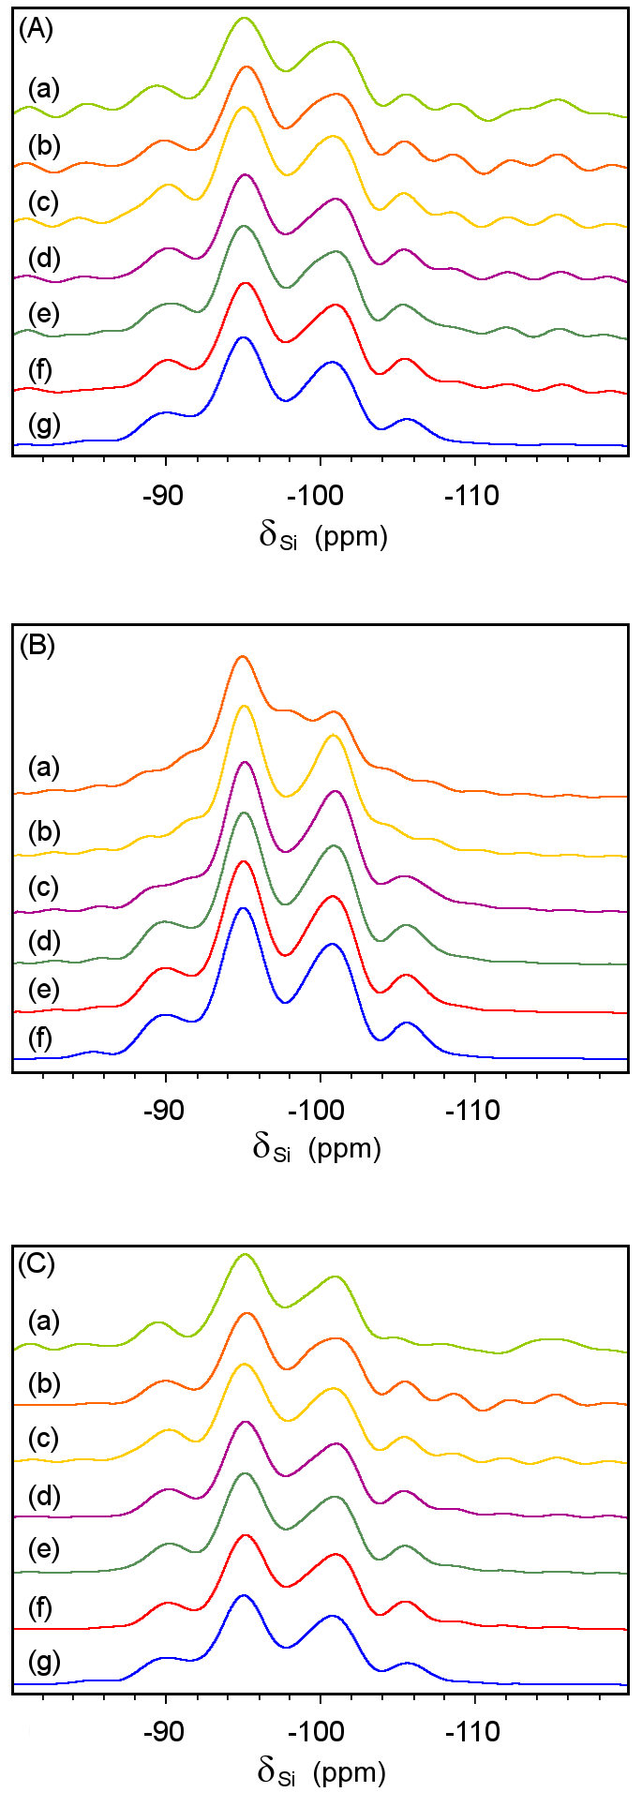
Fig. S1. ²⁹Si MAS spectra of Y zeolite (LZY-64): (A) Spectra acquired with (a) 56 scans or 10 min of machine time; (b) 112 scans, 19 min; (c) 168 scans, 28 min; (d) 224 scans, 37 min; (e) 280 scans, 47 min; (f) 336 scans, 56 min; (g) 8400 scans, 23 h. (B) Denoised spectra acquired with 8400 scans or 23 h of machine time, where the first 1 (a), 2 (b), 3 (c), 4 (d), 5 (e) and 10 (f) singular values were considered. (C) Spectra shown in (A) denoised with the first 10 singular values.
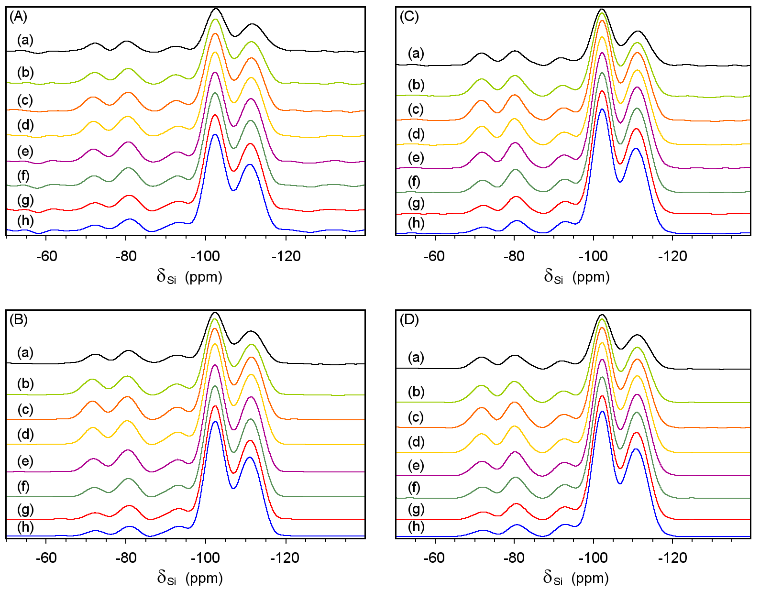
Fig. S2. TPPM-15 high-power proton decoupled ²⁹Si MAS QCPMG spectra of hybrid material: (A) Spectra acquired with 240 scans or 12 h of machine time, Fourier transformed of the FID alone (a), the FID and 1 (b), 2 (c), 3 (d), 4 (e), 5 (f), 6 (g) or 7 (h) co-added echoes. (B) Spectra shown in (A) where the FID and echo train signal were denoised with the first 25 singular values. (C) Spectra acquired with 1200 scans or 60 h of machine time, Fourier transformed of the FID alone (a), the FID and 1 (b), 2 (c), 3 (d), 4 (e), 5 (f), 6 (g) or 7 (h) co-added echoes. (D) Spectra shown in (C) where the FID and echo train signal were denoised with the first 25 singular values.
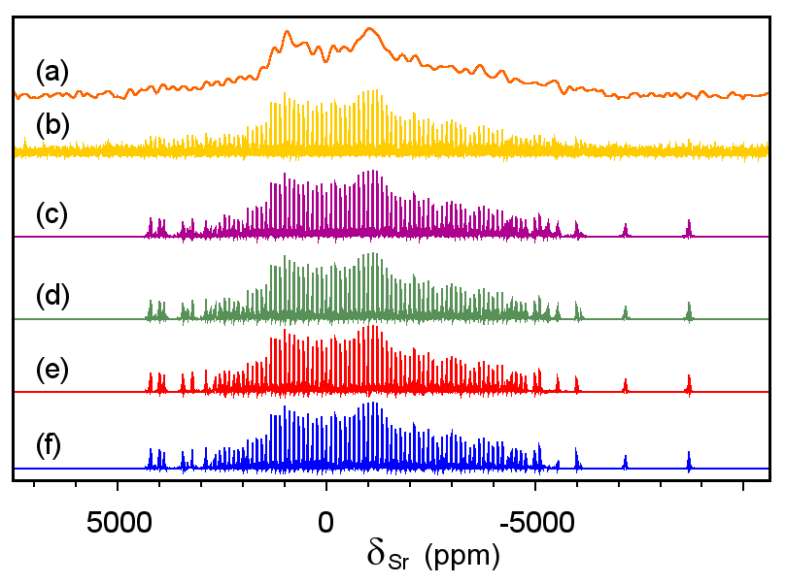
Fig. S3. ⁸⁷Sr static spectra acquired with DFS-WURST-QCPMG sequence: (a) spectrum from co-adding echoes; (b) non-denoised spikelet spectrum; denoised spikelet spectra using 7600X400 (c), 7500X500 (d), 7400X600 (e) and 7300X700 (f) Hankel matrices; the first 80 singular values were considered. The SVD durations without GPU were 4.75 (c), 6.25 (d), 7.00 (e) and 9.50 min (f).
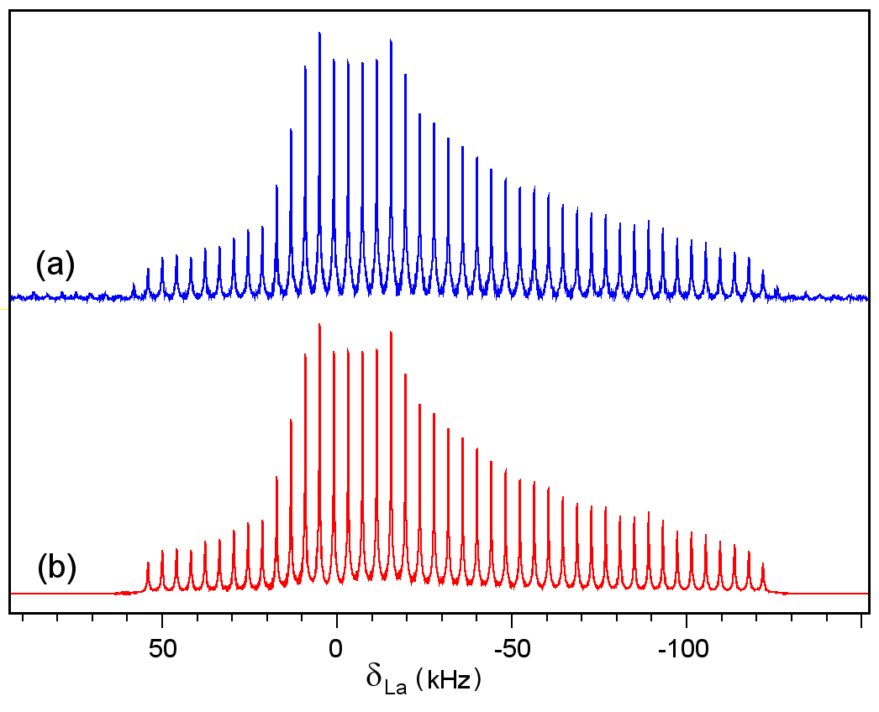
Fig. S4. ¹³⁹La static spikelet spectra of LaCl₃ acquired with QCPMG sequence: (a) non-denoised spectrum composed of 45 spikelets; (b) denoised spectrum using N_{SVD} = 43.
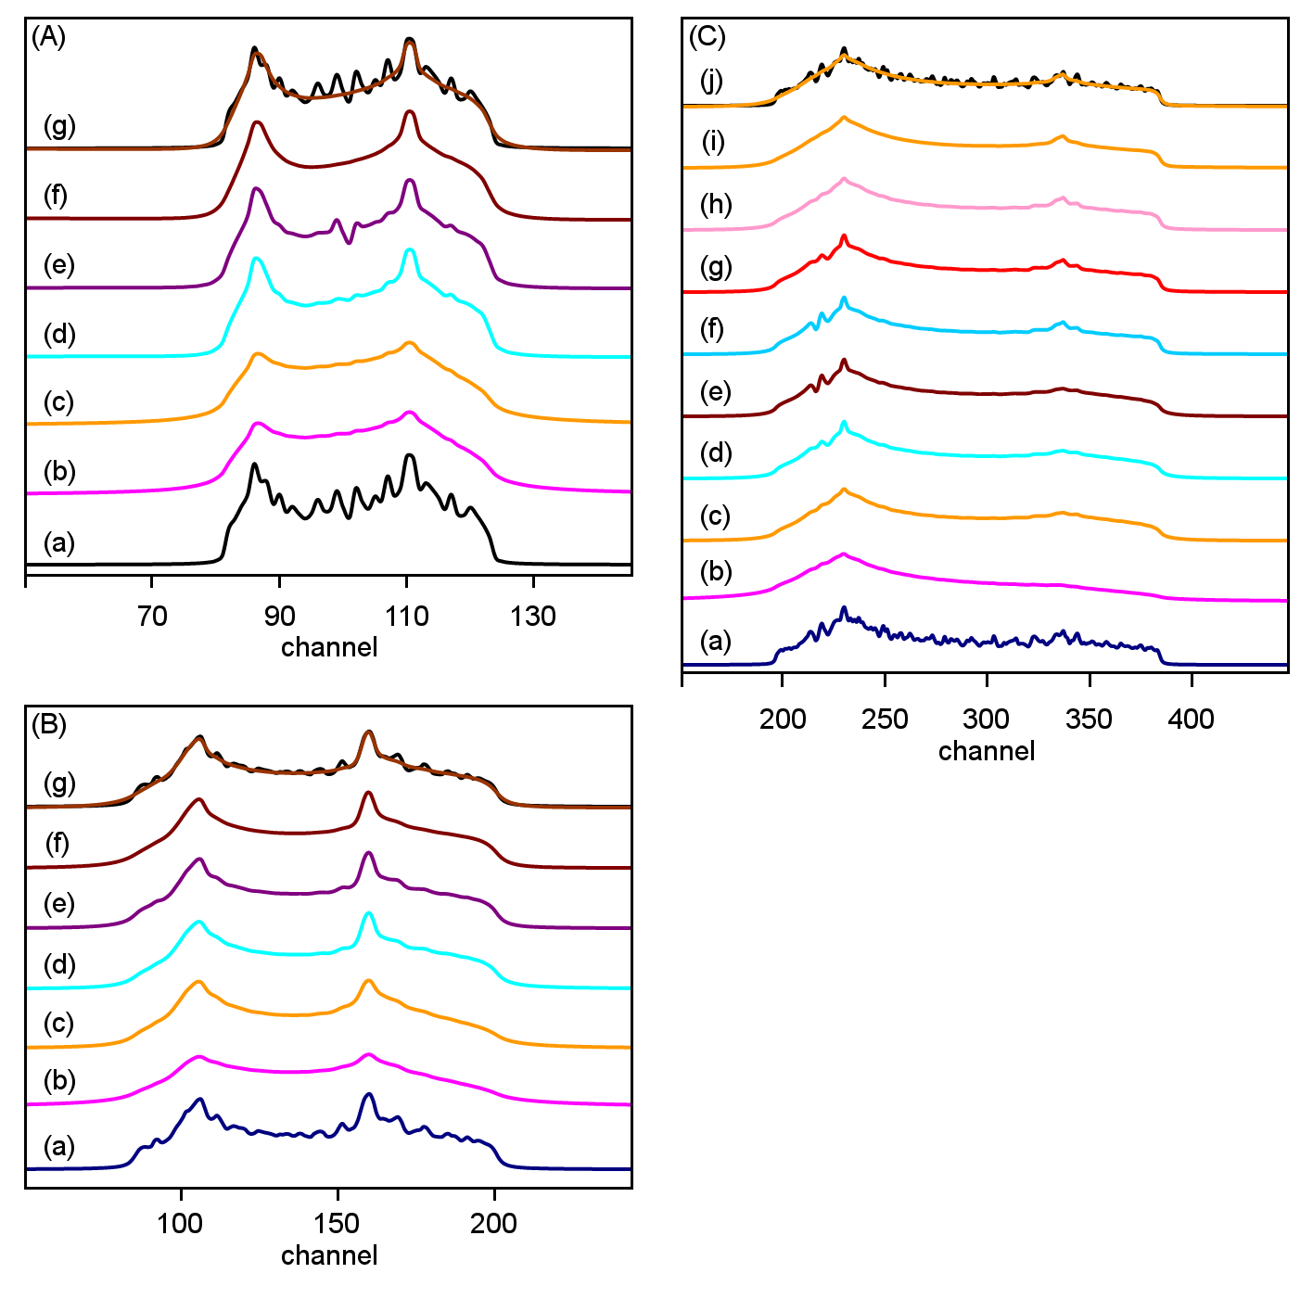
Fig. S5. SIMPSON simulated static CSA and second-order quadrupole spectra with parameters defined in Table S4: (A) (a) non-denoised spectrum; spectra denoised with the first 1 (b), 2 (c), 3 (d) and 4 (e) singular values; (f) twice with the first 3 singular values; (g) superposition of (a) and (f). (B) (a) non-denoised spectrum; spectra denoised with the first 1 (b), 2 (c), 3 (d) and 4 (e) singular values; (f) twice with the first 4 singular values; (g) superposition of (a) and (f). (C): (a) non-denoised spectrum; spectra denoised with the first 1 (b), 2 (c), 3 (d), 4 (e) and 5 (f) singular values; (g) the first 5 singular values where $Σ_{4}$ = 0; (h) the first 5 singular values where $Σ_{4}$ = $Σ_{3}$ = 0; (i) is (h)-processing followed by (f)-processing; (j) superposition of (a) and (i).
References
[1] Wikipedia, Singular Value Decomposition, Available at: http://en.wikipedia.org/wiki/Singular_value_decomposition, Accessed January 2014.
[2] J. Demmel, Singular value decomposition, in: Z. Bai, J. Demmel, J. Dongarra, A. Ruhe, H. van der Vorst (Eds.), Templates for the Solution of Algebraic Eigenvalue Problems: A Practical Guide, SIAM, Philadelphia, 2000, Available at: http://web.eecs.utk.edu/~dongarra/etemplates/, Accessed January 2014.
[3] G.W. Stewart, On the early history of the singular value decomposition, Department of Computer Science and Institute for Advanced Computer Studies, University of Maryland, 1992, , Available at: http://conservancy.umn.edu/bitstream/1868/1/952.pdf, Accessed January 2014.
[4] W.H. Press, B.P. Flannery, S.A. Teukolsky, W.T. Vetterling, Numerical Recipes in FORTRAN: The Art of Scientific Computing, 2nd ed., Cambridge University Press, Cambridge, 1992, , Available at: http://apps.nrbook.com/fortran/index.html, Accessed January 2014.
[5] P.P. Man, 2012 Java Application for FID Denoising with SVD, Available at: http://www.pascal-man.com/navigation/faq-java-browser/SVD-Java-application2012.shtml, Accessed January 2014.
[6] G.W. Stewart, JAMPACK: a Java package for matrix computations, Department of Computer Science, Institute for Advanced Computer Studies, University of Maryland; Mathematical and Computations Sciences Division, NIST, Available at: ftp://math.nist.gov/pub/Jampack/Jampack/AboutJampack.html, Accessed January 2014.
[7] P.P. Man, Graphic Processing Unit (GPU), 2012 SVD Java 6 Application for FID Denoising, Available at: http://www.pascal-man.com/navigation/faq-java-browser/SVD-Java-application-GPU.shtml, Accessed January 2014.
[8] J.R. Humphrey, D.K. Price, K.E. Spagnoli, A.L. Paolini, E.J. Kelmelis, CULA: Hybrid GPU accelerated linear algebra routines, in: E.J. Kelmelis (Ed.), The International Society for Optical Engineering, 2010, Available at: http://www.culatools.com/wp-content/uploads/2011/02/SPIE2010-CULA1.pdf, Accessed January 2014.
[9] J. Klinowski, Nuclear magnetic resonance studies of zeolites, Prog. Nucl. Magn. Reson. Spectrosc. 16 (1984) 237–309.
[10] J. Trebosc, J.W. Wiench, S. Huh, V.S.-Y. Lin, M. Pruski, Studies of organically functionalized mesoporous silicas using heteronuclear solid-state correlation nmr spectroscopy under fast magic angle spinning, J. Am. Chem. Soc. 127 (2005) 7587–7593.
[11] R.W. Schurko, I. Hung, C.M. Widdifield, Signal enhancement in NMR spectra of half-integer quadrupolar nuclei via DFS-QCPMG and RAPT-QCPMG pulse sequences, Chem. Phys. Lett. 379 (2003) 1–10.
[12] L.A. O’Dell, R.W. Schurko, QCPMG using adiabatic pulses for faster acquisition of ultra-wideline NMR spectra, Chemical Physics Letters. 464 (2008) 97–102.
[13] F.H. Larsen, H.J. Jakobsen, P.D. Ellis, N.C. Nielsen, High-field QCPMG-MAS NMR of half-integer quadrupolar nuclei with large quadrupole couplings, Mol. Phys. 95 (1998) 1185–1195.
[14] C. Bonhomme, C. Gervais, N. Folliet, F. Pourpoint, C.C. Diogo, J. Lao, E. Jallot, J. Lacroix, J.-M. Nedelec, D. Iuga, J.V. Hanna, M.E. Smith, Y. Xiang, J. Du, D. Laurencin, ⁸⁷Sr solid-state NMR as a structurally sensitive tool for the investigation of materials: Antiosteoporotic pharmaceuticals and bioactive glasses, J. Am. Chem. Soc. 134 (2012) 12611−12628.
[15] I. Hung, Z. Gan, On the practical aspects of recording wideline QCPMG NMR spectra, J. Magn. Reson. 204 (2010) 256–265.
[16] B. Herreros, P.P. Man, J.-M. Manoli, J. Fraissard, Solid-state ¹³⁹La NMR investigation of lanthanum-exchanged Y zeolites, J. Chem. Soc. Chem. Commun. (1992) 464–466.

